Method of deuteron Electric Dipole Moment search in storage ring with imperfection
A new method of searching for the deuteron electric dipole moment in a storage ring with imperfections is described. The method is based on four fundamental features: the total spin precession frequency in vertical plane due to the electric and magnetic dipole moments in an imperfect ring is measured with absolute accuracy value ~10⁻⁹ rad/sec; a position of the ring elements from the clock-wise to counter-clock-wise procedures is unchanged; the calibration of the effective factor Lorentz using the spin precession frequency measurement in the horizontal plane alternately in each CW and CCW procedures is done; the approximate relationship between the frequencies of the spin in different planes to exclude them to mix to the vertical frequency detecting expected EDM signal at a statistical sensitivity level approaching 10⁻²⁹ e cm is fulfilled.

One of the essential problems of modern physics is the baryon asymmetry of the Universe that represents the prevalence of matter over antimatter [1]. In addition, cosmic detectors, whose purpose is to search for antimatter, PAMELA and AMS haven’t found any significant amount of it in the Universe yet [2]. The development of the new idea that claims one of the reasons for the baryon asymmetry is the breaking of CP invariance, has begun soon after its discovery. A. Sakharov established the necessary conditions for baryogenesis (initial creation of baryons) in 1967 [3]. Many theories beyond the Standard Model have been proposed and all of them of so-called "New Physics" are able to remove the difficulties that one meets in the SM, but their experimental confirmation has yet to be found. One of the possible arguments for the breaking of CP-invariance is the existence of non-vanishing electric dipole moments (EDM) of elementary particles.
The idea of searching for the electric dipole moment (EDM) of the proton and the deuteron using polarized beams in a storage ring was originally proposed at Brookhaven National Laboratory (BNL) [4], and it is based on so-called frozen spin (FS) method. The concept of “frozen spin” lattice consists of deflectors with incorporated electric and magnetic fields in one element, when the spin of the reference particle is always orientated along the momentum. Under this condition, the signal growth of presumably existing electric dipole moment is maximized. This is clearly evident from the Thomas-Bargmann-Michel-Telegdi equation:
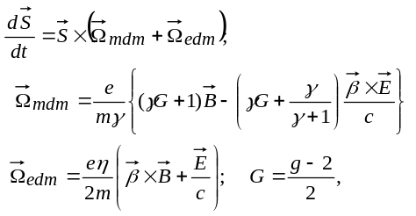(1)
where is the anomalous magnetic moment, is the gyromagnetic ratio, 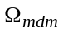 is the spin precession frequency due to the magnetic dipole moment (hereinafter called MDM precession), 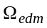 is the spin precession frequency due to the electrical dipole moment (hereinafter called EDM precession), and is the dimensionless coefficient defined by the relation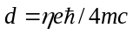in (1).
It is reasonable to implement the frozen spin method in a purely electrostatic machine (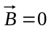) with electrical deflectors holding a beam on orbit. The advantages of purely electrostatic machines are especially evident at the “magic” energy, when
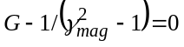, (2)
and the spin oriented in the longitudinal direction rotates in horizontal plane with the same frequency as the momentum 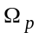, that is 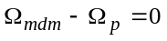.
However, this method cannot be used for deuterons having the negative anomalous magnetic moment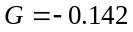, which follows from condition (2). Therefore, the only possible method in this case is a storage ring with both electric and magnetic fields [5]. It was proposed to store a longitudinally polarized deuteron beam of 1 GeV/c total momentum in an electro-magnetic storage ring, where they minimize the MDM precession with respect to momentum 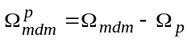. This can be done by applying a radial electric field 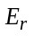 of magnitude to balance the vertical magnetic field 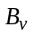 contribution to 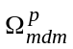 in Eq. (1):
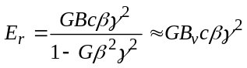 (3)
Thus, in both proton and deuteron rings it is planning to realize the concept of frozen spin. In this sense, they have a general idea of constructing a ring, but which is realized with the help of deflectors of different types. These differences do not play an essential role for the spin-orbital motion, so long as we are considering the motion of the reference particle in the perfect ring without misalignments.
The presence of errors in the installation (misalignments) of the elements of the ring leads to the appearance of vertical 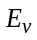and radial 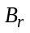 components of the electric and magnetic fields respectively. They both change the spin components in the vertical plane, where we expect the EDM signal, and create the systematic errors initiating the “fake EDM” signal.
To solve this problem in the case of a proton beam, it was suggested to use the procedure of simultaneous injection of two beams in the ring in two opposite directions, clock-wise (CW) and counter-clock-wise (CCW) [5]. If in CW direction the deviation of the spin in the vertical plane due to MDM and EDM is added, then in CCW direction they are subtracted. Adding the CW and CCW results, the EDM can be separated from a systematic error arisen due to MDM. However, this method is possible only in a purely electrostatic ring, since the deflecting force of the electric field does not depend on the direction of the charged particle, and both beams can be simultaneously in the ring. In the case of a deuteron ring, the magnetic component of the Lorentz force depends on the direction of motion, and therefore the polarity of magnetic field is required to be changed when the direction of injection is different.
Therefore, there is a global problem of how to restore the magnetic field after a change polarity, since the error of field recovery should not exceed the expected value of EDM, and this problem practically closes the possibility of deuteron EDM investigating in the ring. This is main argument that the different approach is required for the deuteron ring.
Additionally to that due to the misalignments of the ring elements, the arising radial magnetic 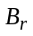 and vertical electric components act differently on the spin. If even we assume that the equality of vertical component of the Lorentz force averaged over the ring 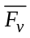 is exactly zero due to ideal adjusting of fields in elements of the ring to provide the stable motion [5]
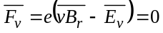, (4)
nevertheless we would have a non-zero rotation of the spin in the vertical plane, that is the “fake EDM” signal [1]. Assuming that number of arbitrary elements of the size are installed on the ring with the rms vertical error 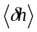, and the condition (4) for them is fulfilled. From (1) and (4) we can get the standard deviation of MDM spin precession frequency in a vertical plane around the radial axis:
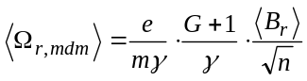 , (5)
where 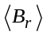 is the rms value of the radial magnetic field. Here, we no longer subtract the momentum frequency like we did in horizontal plane (1), since in a vertical plane the frozen condition (2) does not work. By the way, such a high sensitivity to errors occurs in a purely electrostatic ring, as well. So, the value of the radial component of the field 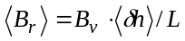 is determined by the slope of the magnet 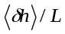 in transverse plane around the longitudinal axis and the vertical component of magnetic field . Let's take more or less realistic value of rms error installation of arbitrary magnet =100μ. At the size magnets L≈1 m and the total number of elements on the ring n≈100 the spin precession frequency in vertical plane will be of the order of 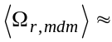100 rad/sec. The numerical simulation of spin-orbital motion in the design lattice using the COSY Infinity code [6] gives a frequency value of about 3 times less, which indicates that the formula (5) can be applied for the order estimation enough successfully. Now let's compare the frequency of spin precession due to a presumably existing EDM with the frequency caused by MDM. The latter, mixed with EDM, gives a fake signal, giving a systematic error in our future experiment. Substituting the ring design parameters 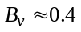T and 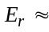12 MV/m in (1), we can determine the spin precession frequency in the vertical plane caused by the assumed EDM 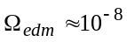rad/sec. In the BNL experiment proposal for EDM search [5] it is planning to measure the value of the vertical component of the spin initiated by EDM at the level of 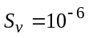, which is reached in 1000 seconds. Obviously, with this approach, we must lower the MDM contribution to a level below the expected value of the EDM. Following this requirement, we must increase the accuracy of the geodetic installation by more than 11 orders of magnitude up to unrealistic value of 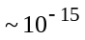 m. Thus, we are really deprived of ability to measure the accumulated EDM signal by growth of the vertical component of spin suggested in [5], since the spin rotation due to the magnet errors is much faster than due to possibly existing EDM 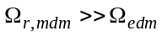.
Therefore, we propose to measure not the magnitude of the vertical component of spin, but the total precession frequency of the spin due to the EDM and MDM. In order to split out the EDM signal from the sum signal, we need an additional condition. Such a condition is to measure the total spin frequency in the experiment with a clock-wise direction of the beam
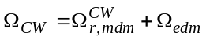 (6)
and compare with a counter clock-wise measurements
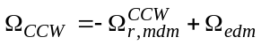 (7)
Obviously, the sum of the frequencies of these two signals
(8)
will allow us to identify the frequency of the EDM signal, which in turn gives the EDM value. But here are four problems, and all of them require special consideration.
First, we see from (8) that the accuracy of the frequency measurement of 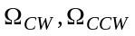 determines the precision of the EDM measurement. In [7] one has been shown that the relative accuracy of the spin frequency measurement 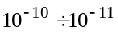 is achievable for the case when the polarimeter measurement frequency is much less than the spin precession frequency. In our case, we have an inverse relationship between the polarimeter rate and the measured spin frequency, which extends the range of frequencies where statistical estimates are legitimate. For a statistical absolute error of measuring a frequency of the spin oscillation one can use: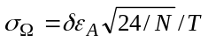, where 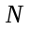 is the total number of recorded events, 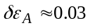 is relative error in measuring the asymmetry and 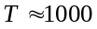sec is the measurement duration [8]. If we assume that we have a beam of 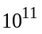 particles per fill and a polarimeter efficiency of one percent, then we have the frequency error definition 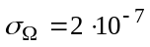. At the average accelerator beam time of 6000 hours per year, we can reach 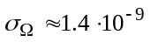rad/sec with one-year statistics. Taking into account that formula (1) at EDM 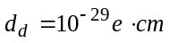gives the value of the spin precession frequency 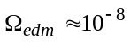, we can say that such accuracy of frequency is quite satisfactory and can provide to reach 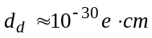 at parameter 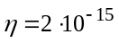.
Secondly, the main idea of using CW-CCW is based on the fact that the contribution of MDM spin rotation is to be the same for both CW and CCW directions. In ideal case the difference 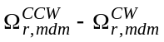 is zero, however, it is not so indeed. In reality, we do not know how accurately the field is recovered after change of polarity, and besides the CW, CCW beams trajectory can be different, which in turn gives own contribution into the MDM spin precession frequency. Therefore let's reformulate the global problem of how to restore the conditions for the equality of the contribution of MDM spin rotations after change polarity of magnetic field (no change for electrical field) in the plane where we are going to measure the EDM in order to get the difference smaller than the expected EDM precession frequency 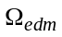 (see eq. 8). In this regard, we are going to do two procedures. The first follows from the study of suppression of the spin decoherence [9], where we concluded, that two particles having different orbits with different initial conditions in the transverse planes and different initial energy deviations are assumed to be the same, from the point of view of the spin behavior, if they have the same spin tune, and it is reached when the length of particles orbit are equal. We call this conditions of zero decoherence of spin precession. Equation (8) quoted from [9] shows this dependence:
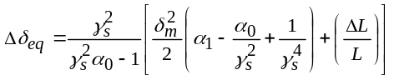, (8)
where 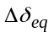is shift of the equilibrium level of momentum due to the orbit lengthening in transverse plane 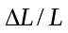 and due to synchrotron oscillation with amplitude 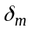. Values 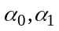are the zero and first order momentum compaction factors, 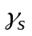 is Lorentz factor of synchronous particle. The new equilibrium energy 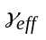, which we call hereinafter effective factor Lorentz, is:
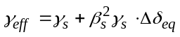. (9)
This parameter is named so, because it includes three spatial coordinates and completely determines the frequency of spin precession in all three planes. Adjustment of the length of the orbit of each particle is effected by the sextuples, introducing the dependence of the action of the sextupole field on the amplitude of transverse oscillations and the energy deviation from the reference particle. Now we can transfer this important conclusion to the beams moving in two opposite directions CW and CCW, namely: the beams are identical in terms of the behavior of the spin, if they have the same effective factor Lorentz averaged over all particles in beam. That is unimportant on what trajectory the beams move in opposite directions CW and CCW and what is their energy, it is important the equality of their effective Lorentz factors averaged over beams. This important condition gives us to obtain identical frequencies of spin precession for beams moving along different trajectories.
Now let us turn to the third important circumstance, and assume that we have two rings with a direct (CW) and reverse sequence of elements (CCW) with changed polarity of magnetic field. The similarity of these rings is only that the position of all elements of the ring and, consequently, the relation between the values of the vertical and radial components of the field remains unchanged
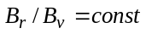 and 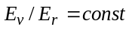 (10)
Here we should take into account mentioned above two facts that, first, we will not change the polarity of the electric field, leaving it unchanged during the transition from CW to CCW option and secondly, when the energy raises, the equilibrium condition for particles will be maintained by changing the magnetic field only. Therefore in the future we will focus our attention on the magnetic field only. Regardless of this circumstance, the probability that the reverse trajectory coincides with the direct trajectory is unrealistic, and it can be reason to have the different orbit length and hence different factor Lorentz values that determine the spin precession frequency in all planes. Therefore, before changing the polarity, we must calibrate the gamma around the vicinity of the value 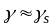 using measurements of the precession frequency of the spin in the horizontal plane where no EDM signal and then restore the same in the ring with the reverse sequence of elements. For such a calibration, we need to reduce the spin oscillation in the vertical plane to a small value, for example, by introducing a transverse solenoid with a magnetic field of order 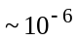Tesla installed on the straight section. Here we want to notice that to slow the spin rotation in the vertical plane it does not mean, that we introduce here the magnitude of the magnetic field in the solenoid, as a parameter requiring precise determination. The only purpose of introducing a solenoid is that the relative contribution of the vertical frequency into the horizontal frequency should be less than the required calibration accuracy, namely 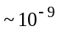, and since they add up as squares of frequencies, this is easily realizable. The transverse solenoid is switched on only for the time of calibration of the in the CW ring and for the time of its recovery in the CCW ring. Since we can calibrate the frequency, that is , with mentioned above absolute value of errors 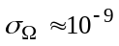rad/sec and taking into account the constant relation between the vertical and the radial components of field (10) it means that in the case of CCW we have a ring in terms of the behavior of the spin identical to the CW ring, and we can get with accuracy 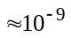.
Finally, we will consider the fourth important point in the proposed procedure for measuring EDM. This problem is due to the fact that the spin oscillation in any of the planes includes the spin oscillation in other two planes. Let’s write the solution of equation (1) at the initial conditions for horizontal, vertical 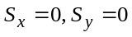 and for longitudinal components 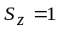in the general form:
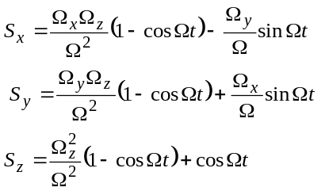, (11)
where in our case 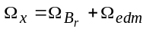and 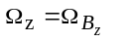arise due MDM rotation in imperfect ring and the EDM, 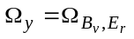is MDM spin rotation relative of the momentum in the leading magnetic and electric fields and 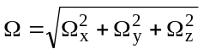 is the module of three dimensional frequency. As follows from the above that we are going to measure the precession frequency of the spin in a vertical plane, that is, to study the behavior of the oscillating part of 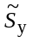, let us write the solution of it:
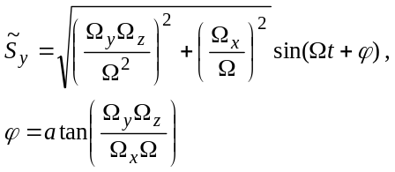, (12)
Since the amplitude and the phase of the signal do not play a role in the measurement, we are only interested in the frequency:
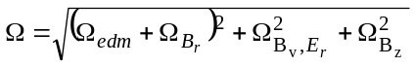 (13)
Assuming that in accordance with the frozen spin concept we keep the spin along the momentum 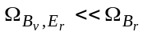and 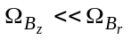,it is realized by introducing a second solenoid with the longitudinal magnetic field, we can write:
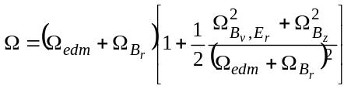 (14)
From this relation the restriction follows on the values of 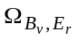 and 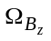, the contribution of which ones should be less than the addition from the EDM to the total frequency :
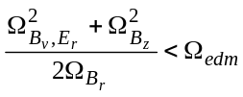 (15)
Let's evaluate these requirements numerically, how difficult to implement it technically. For instance, 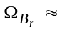100 rad/sec and 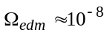rad/sec, then 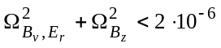 or both have to be 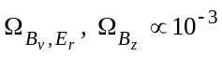. That is for the spin coherence time 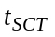~1000 sec the spin rotation should not exceed more than 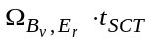~1rad and 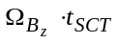~1rad, which is easily achievable for 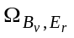 due to calibration of energy and for due to the introduction of a longitudinal solenoid. As in the case of a transverse solenoid, the knowledge of the field in the solenoid does not need to be known exactly, since it is needed to satisfy relation (15) only, which has an approximate character.
Thus, we can conclude that the misalignments of ring elements, which previously played a limiting role in the measurement of EDM, now provide a precession of the spin in the vertical plane, with the help of which it is proposed to measure the EDM. The limitation on frequencies in the vertical plane during a calibration and in the horizontal and longitudinal planes during measurement has an approximate character and does not require exact knowledge of the fields in the correcting solenoids. Thus, we propose to solve the fundamental problem of measuring the deuteron EDM in a ring with imperfection. The estimates show that the lower limit of detection of presumably existing EDM can be as low as ~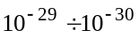 e·cm for a measurement. The authors wish to thank the JEDI collaboration for scientific discussion and for their support to make this work.
References
[1] Canetti L., Drewes M., Shaposhnikov M. (2012). "Matter and Antimatter in the Universe", New Journal of Physics, 14, 095012.
[2] Aguilar M., Alberti G., Alpat B. et al., (2013) "First Result from the Alpha Magnetic Spectrometer on the International Space Station: Precision Measurement of the Positron Fraction in Primary Cosmic Rays of 0.5 - 350 GeV", Phys. Rev. Lett., 110, 141102.
[3] Sakharov A. (1967). "Violation of CP Invariance, C Asymmetry, and Baryon Asymmetry of the Universe", Letters to Jounal of Experimental and Theoretical Physics, 5, 24- 26.
[4] F. J. M. Farley, K. Jungmann, J. P. Miller, W.M. Morse, Y. F. Orlov, B. L. Roberts, Y. K. Semertzidis, A. Silenko, and E. J. Stephenson, New Method of Measuring ElectricDipole Moments in Storage Rings, Phys. Rev. Lett. 93,052001 (2004).
[5] D. Anastassopoulos et al., “AGS Proposal: Search for a permanent electric dipole moment of the deuteron nucleus at the 10−29 e · cm level”, BNL, 2008.
[6] M. Berz, “Computational Aspects of Design and Simulation: COSY INFINITY”, NIM A298, (1990).
[7] D. Eversmann et al., New method for a continuous determination of the spin tune in storage rings and implications for precision experiments, Phys. Rev. Lett. 115, 094801 (2015)
[8] A. Aksentyev and Y. Senichev, Statistical precision in charged particle EDM search
in storage rings, Proceedings IPAC 2017.
[9] Y. Senichev et al., Spin Tune Decoherence Effects in Electro- and Magnetostatic Structures”, Proceedings of IPAC 2013, Shanghai, China, pp. 2579-2581

